Baseline
Baseline Model Report

Analytic Approach
Target Definition
The primary target variable for this project is LN_IC50, which is defined as the natural logarithm of the half-maximal inhibitory concentration of the drug used to treat the cell line. LN_IC50 was selected because it provides the best balance of statistical dispersion, biological interpretability, and alignment with established GDSC drug-response endpoints, compared to alternatives such as the AUC and Z-score. The modeling task is framed as a supervised regression problem, with LN_IC50 treated as a continuous outcome, enabling precise prediction of drug sensitivity across diverse cancer cell lines.

Inputs
The model inputs were constructed from a carefully engineered set of biological, genomic, tissue, and drug-related features. The final modeling dataset includes drug identity (DRUG_NAME), mechanism-level information describing drug targets (TARGET_PATHWAY), standardized cancer classifications (TCGA_DESC), and tissue-level descriptors (GDSC Tissue descriptor 1 and GDSC Tissue descriptor 2). These are complemented by phenotypic indicators such as microsatellite instability (MSI) and growth properties, as well as genomic predictors including mutational_burden and ploidy estimates derived from SNP array and whole-exome sequencing (ploidy_snp6 and ploidy_wes). The feature engineering pipeline included imputing missing values, one-hot encoding low-cardinality categorical variables, target encoding high-cardinality features such as DRUG_NAME, and standardization of continuous predictors. In addition, feature selection was supported using mutual information analysis and repeated subsampling to identify and retain the most informative predictors.

Type of model Built
The baseline model used in this project was a supervised regression framework developed by comparing various models, such as linear models, tree-based models, and neural network approaches. This provided a useful starting point, as it allowed us to evaluate the effectiveness of the cleaned feature set in capturing the main structure of the drug-response data, before applying more advanced tuning or ensembling techniques. Among these options, gradient boosting methods (CatBoost, XGBoost, and LightGBM) emerged as the most effective starting point because they are well-suited to tabular data and can model the nonlinear relationships and feature interactions that are common in biological response data. However, the baseline model had several limitations, such as reliance on default or lightly tuned parameters, sensitivity to preprocessing choices, and risk of leakage when using high-cardinality features. As a result, the baseline model was useful for establishing initial performance, but it was not yet the most reliable or best-performing version of the pipeline.

Feature Engineering
Missing-Value Handling
Missing values were handled before model training, so the models could use the full cleaned dataset. For the numeric genomic features, mutational_burden, ploidy_snp6, and ploidy_wes, missing values were replaced using median imputation, with the median calculated from the training data only and then applied to both the training and test sets. Median imputation was used because these genomic variables are continuous and may be skewed, so the median is less affected by extreme values than the mean.
For categorical missing values, they were handled before encoding. The MSI column was filled as a separate “MISSING” category so the model could retain those rows and treat missing MSI status as its own category during one-hot encoding. Other categorical fields, such as tissue descriptors, growth properties, and TCGA labels, were filled where possible using validated supplementary sources matched by COSMIC_ID; remaining categorical values were handled before one-hot encoding so they would not break the modeling process.

Encoding
Encoding was used to convert categorical predictors into numeric features that the machine learning models could interpret. Two encoding strategies were used because the categorical variables had different levels of complexity.
Lower-cardinality categorical features including TCGA cancer labels, GDSC tissue descriptors, Growth Properties, MSI status, & TARGET_PATHWAY, were handled with one-hot encoding. One-hot encoding was appropriate for these variables because they represent categories without a natural numeric order. This allowed the models to use cancer type, tissue context, growth behavior, MSI status, and drug-pathway information without incorrectly treating the categories as ranked values.
DRUG_NAME was handled separately using cross-validation target encoding because it was highly predictive of the target variable and had many unique drug categories. One-hot encoding DRUG_NAME would have created a very large and sparse feature space. Target encoding replaced each drug name with a numeric value based on that drug’s average LN_IC50 pattern. Cross-validation target encoding was used to reduce data leakage because the encoded values were learned from training folds instead of directly using each row’s own target value.
This was important because drug identity was expected to carry a strong predictive signal, but it needed to be represented carefully so the model could learn drug-response patterns without simply memorizing the target.

Standardization
Quantile transformation was used to scale selected numeric predictors after encoding and imputation. The transformed numeric columns were: DRUG_NAME_target_enc, mutational_burden, ploidy_snp6, & ploidy_wes. Quantile transformation was useful because these numeric features may not follow a normal distribution. Instead of only centering and scaling values like StandardScaler, QuantileTransformer reshapes the feature distribution using quantiles.
This helped reduce the effect of skewed distributions and extreme values in genomic predictors such as mutational_burden. The transformer was fitted only on the training data and then applied to both the training and test sets. This prevented information from the test set from influencing the scaling process. One-hot encoded columns were not transformed because they were already binary 0/1 indicators. The final transformed matrices were saved as X_train_scaled & X_test_scaled. These transformed matrices were then passed into the Model algorithms for training and evaluation.

Safe feature name mapping
Safe feature names were created for XGBoost and LightGBM. Encoded feature names can contain spaces, punctuation, parentheses, or long labels. These can sometimes cause compatibility issues.
Feature Selection
The baseline feature selection showed that DRUG_NAME_target_enc was the strongest predictor, meaning drug identity carried the largest signal for predicting LN_IC50. The genomic features ploidy_wes, mutational_burden, and ploidy_snp6 were also highly ranked, suggesting that genomic instability helped explain differences in drug sensitivity.
Growth behavior, especially Growth_Properties_Suspension, and cancer-context variables such as tissue descriptors, TCGA labels, and target pathway features also contributed supporting information.
Overall, the baseline feature selection showed that drug response was influenced by a combination of drug identity, genomic state, and cancer/tissue context, which supported moving toward stronger nonlinear models.

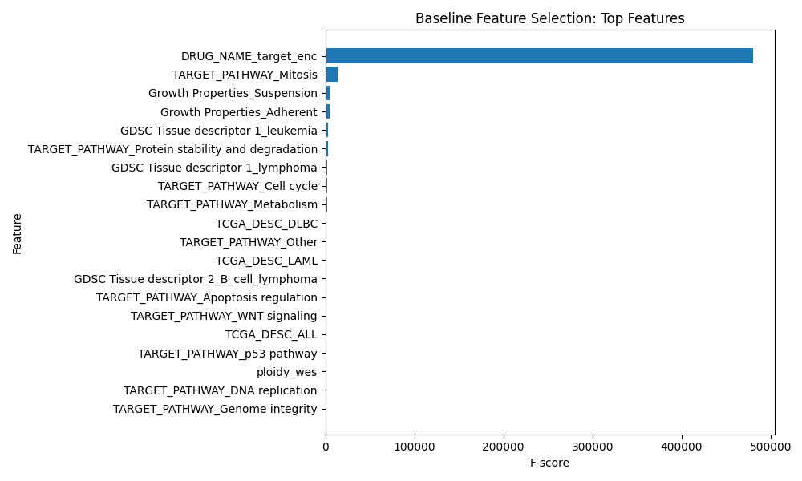
Figure 1: Baseline Feature Selection: Top Selected Features; Shows the strongest baseline-selected predictors, with DRUG_NAME_target_enc dominating the feature ranking.
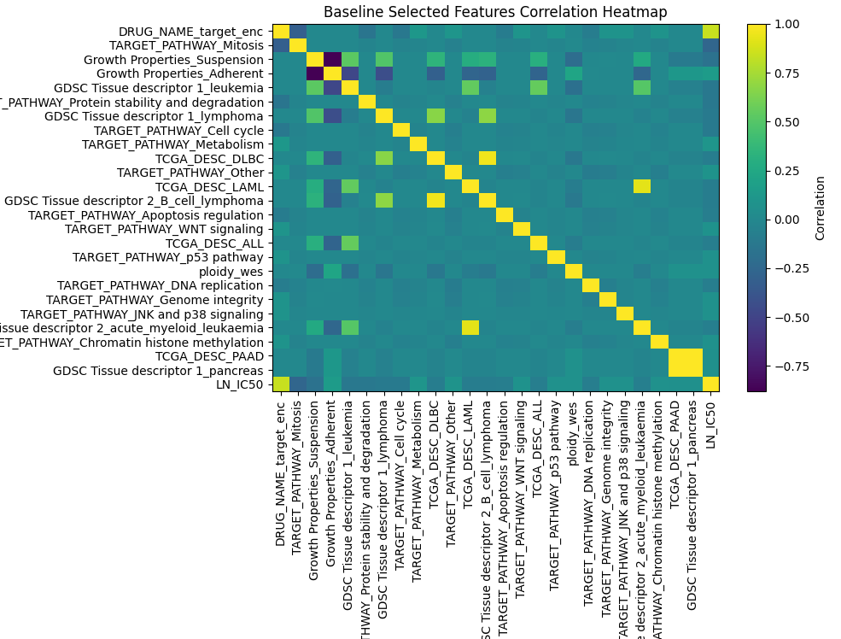
Figure 2: Baseline Selected Features Correlation Heatmap; Displays correlation among selected baseline features and LN_IC50 to check feature overlap and redundancy.

Model Description
Models and Parameters
The modeling pipeline begins with the preprocessed dataset containing drug, genomic, and tissue-level features. Missing values were handled through targeted imputation, followed by encoding strategies tailored to feature type encoding for high cardinality variables such as drug identity. Continuous variables were standardized to ensure consistent scaling across models.
The dataset was split into training and held-out test sets to evaluate generalization performance. Model training was performed on the training set, and predictions were generated on the test set using the same evaluation metrics across models.

Data preprocessing ---> Feature engineering ---> Model Training ---> Evaluation

What learner(s) were used?
Multiple supervised learning algorithms were evaluated to identify the most effective approach for predicting LN_IC50. These included linear models (Linear Regression and Ridge), tree-based ensemble models (Random Forest and Extra Trees), and advanced gradient boosting models such as XGBoost, LightGBM, CatBoost, and HistGradientBoosting.
Among these, gradient boosting models demonstrated the strongest performance due to their ability to capture nonlinear relationships and complex feature interactions within the dataset. In addition, a neural network model (MLPRegressor) was tested to explore potential performance improvements from deep learning approaches.

Learner hyperparameters
Default hyperparameters were initially used to establish baseline performance across all models. Following this, hyperparameter tuning was conducted using optimization techniques such as randomized search and Optuna to improve model performance.
Key hyperparameters tuned for gradient boosting models included Number of trees (n_estimators), Learning rate, Maximum tree depth, Subsampling ratios, and Regularization parameter. For neural network models, parameters such as hidden layer size, activation function, and learning rate were adjusted.
The tuning process resulted in improved predictive performance, particularly for XGBoost and LightGBM, which achieved the best balance between bias and variance on the validation data.
Results (Model Performance)
Model | RMSE | MAE | R²
CatBoost | 1.132169 | 0.843563 | 0.831986
XGBoost | 1.140523 | 0.851656 | 0.829497
MLPRegressor | 1.182636 | 0.888743 | 0.816673
LightGBM | 1.229644 | 0.916978 | 0.80181
HistGradientBoosting | 1.230592 | 0.916503 | 0.801504
ExtraTrees | 1.232253 | 0.911635 | 0.800968
Ridge | 1.344522 | 1.007612 | 0.763048
Table 1: Baseline Model Performance Using Default Settings; Compares RMSE, MAE, and R² across initial baseline models before hyperparameter tuning.

Model | RMSE | MAE | R²
XGBoost(w/ Optuna) | 1.032373 | 0.768512 | 0.8603
LightGBM(w/ Optuna) | 1.035314 | 0.772103 | 0.859503
Catboost(w/ Optuna) | 1.050988 | 0.784145 | 0.855216
HistGradient(w/ Optuna) | 1.099774 | 0.821224 | 0.841463
Catboost | 1.110923 | 0.829804 | 0.838232
Extra Trees | 1.2494 | 0.9181 | 0.7954
Ridge(w/ Optuna) | 1.341 | 1.006 | 0.76426895
Linear Regression | 1.3443 | 1.0079 | 0.7631
HistGradient | 1.396169 | 1.047938 | 0.741699
MLPRegressor | 1.409077 | 1.059455 | 0.7369
Table 2: Baseline Model Performance After Hyperparameter Tuning; Shows improved model performance after preprocessing and tuning, with XGBoost achieving the strongest results.
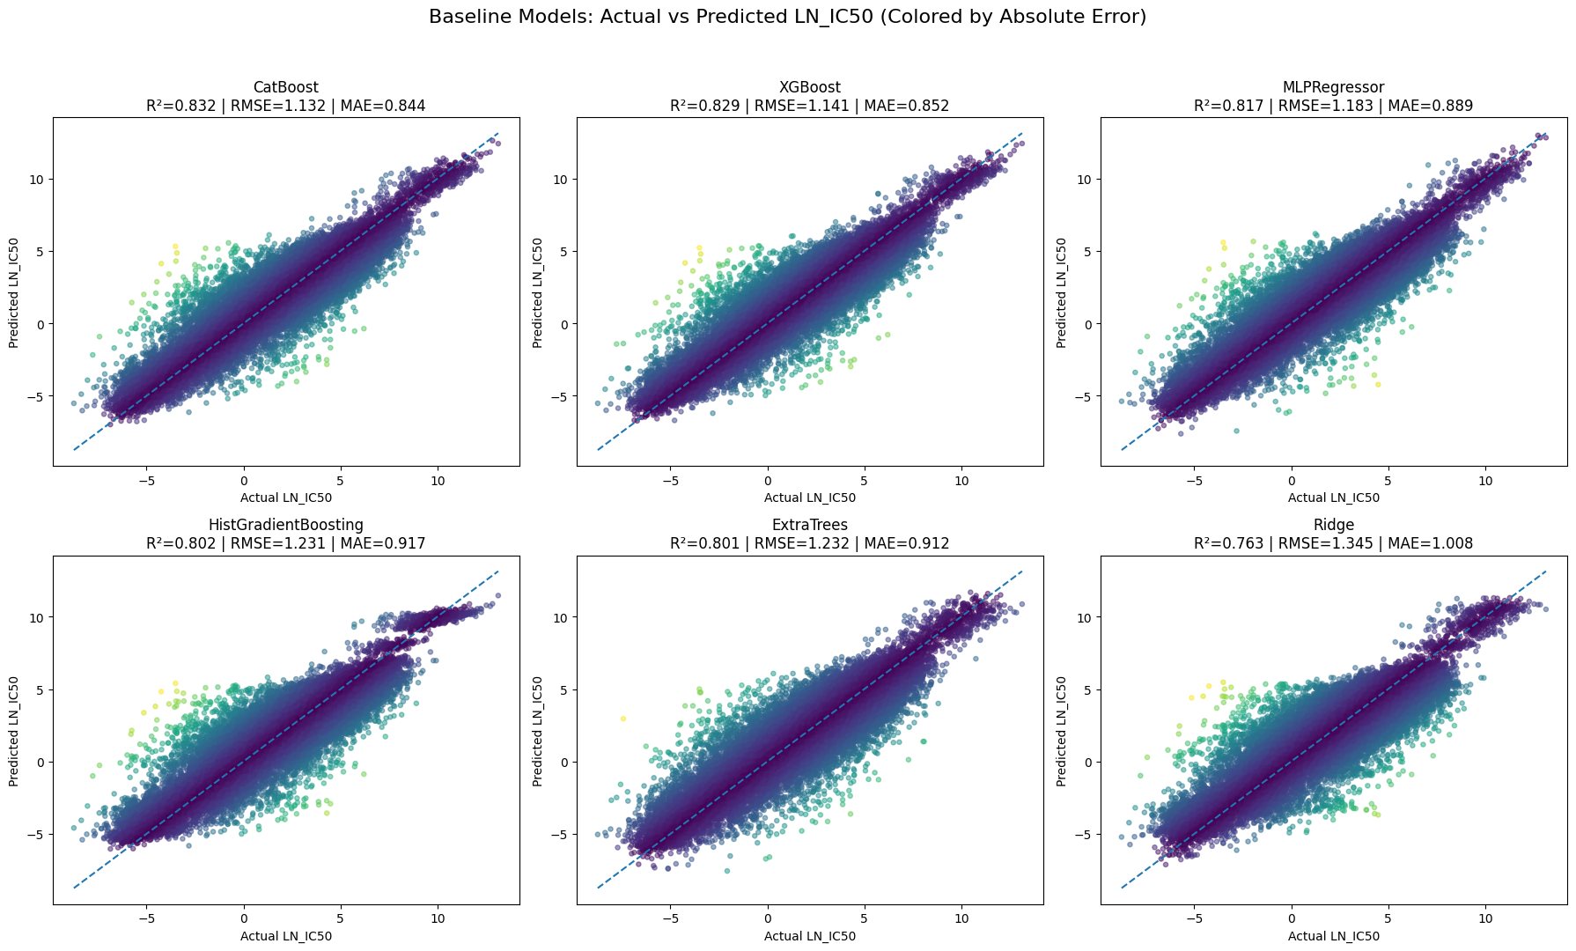
Figure 3: Baseline Actual vs. Predicted LN_IC50 Across Models; Baseline models generally follow the diagonal trend, showing that LN_IC50 prediction is feasible, but stronger boosting models such as CatBoost and XGBoost show tighter prediction patterns than weaker models like Ridge.

After preprocessing, multiple supervised regression models were tested to compare how well they predicted LN_IC50. Based on Table 1, CatBoost performed best among the default baseline models, with the highest R²and the lowest RMSE/MAE. XGBoost followed closely, while MLPRegressor also showed reasonable predictive performance. LightGBM, HistGradientBoosting, and ExtraTrees performed similarly but slightly lower, and Ridge had the weakest results, suggesting that a simple linear model was less effective for this dataset. The table shows the RMSE results for XGBoost at the lowest of about 1.003 which in comparison to the predicted values, is better post hypertuning. The predicted best model was initially CatBoost, but post hyperparameter tuning and preprocessing, it was the third best model. LightGBM came in second for the best. XGBoost uses its fast-paced decision-based machine learning methods to distribute decision trees leading the machine learning techniques for regression, classification, and ranking problems. Due to the high volume of data, nonlinear tree-based and boosting models were better suited for capturing the relationships between drug, genomic, tissue, and pathway features and LN_IC50. Table 2 further shows the hyperparameter tuning improved performance with XGBoost using Optuna. Optuna was utilized to automate and accelerate machine learning techniques. As seen in Figure 3, there is a relatively even distribution across the trend line for all of the predicted vs actual LN_IC50 values. This emphasizes the improvements methods such as preprocessing and hyperparameter tuning to cause the even distribution.

Model Understanding
Variable Importance
The high-cardinality feature, which was separately encoded as DRUG_NAME_target_enc, is the strongest predictor in the baseline feature analysis, indicating that identity carried the most weight in predicting LN_IC50.
The merged numerical features of ploidy_wes, ploidy_snp6, and mutational burden were among the most informative features for the baseline models. Other cancer-context based features like TCGA_DESC, GDSC_Tissue_descriptor_1, GDSC_Tissue_descriptor_2, and TARGET_PATHWAY contributed to the model by supporting the signals that account for the tissue, disease-specific, and pathway response patterns.

Insight Derived from the Model
The baseline models suggest that drug response is mainly explained by a combination of drug identity and biological context, not by one feature alone. The high importance of DRUG_NAME_target_enc indicates that the specific drug being tested carries the largest share of the predictive signal, suggesting that different drugs already have distinct response patterns in the dataset.
The high ranking of ploidy_wes, ploidy_snp6, and mutational_burden suggests that genomic instability and mutation load help explain why some cell lines are more sensitive or resistant to treatment. The contribution of TCGA_DESC, GDSC Tissue descriptor 1, and GDSC Tissue descriptor 2 suggests that cancer type and tissue background provide important context for interpreting response, even if they are not as predictively dominant as drug identity.
The fact that nonlinear models such as CatBoost and XGBoost performed best supports the idea that the relationship between predictors and LN_IC50 is likely complex and interaction-based, rather than purely linear.
Overall, the baseline results suggest that cancer drug sensitivity is influenced by interacting factors across drug, tumor, and genomic levels, which supports the decision to use more flexible machine learning models for later tuned and hybrid comparisons.

Feature | Importance
DRUG_NAME_target_enc | 52.233626
ploidy_wes | 7.43573
mutational_burden | 6.868373
Growth_Properties_Suspension | 6.782117
ploidy_snp6 | 6.470171
TARGET_PATHWAY_ERK_MAPK_signaling | 1.713995
GDSC_Tissue_descriptor_1_leukemia | 1.342382
GDSC_Tissue_descriptor_1_lymphoma | 0.816106
Growth_Properties_Adherent | 0.618551
TCGA_DESC_NB | 0.613951
TCGA_DESC_SCLC | 0.569806
TARGET_PATHWAY_DNA_replication | 0.492163
TARGET_PATHWAY_EGFR_signaling | 0.424365
GDSC_Tissue_descriptor_2_melanoma | 0.404309
TCGA_DESC_PAAD | 0.389557
Table 3: Top Baseline CatBoost Feature Importance Rankings; Ranks the strongest CatBoost predictors, showing drug identity as the dominant signal, followed by genomic, growth, pathway, and cancer-context features.

Feature | Importance
Growth_Properties_Suspension | 0.13522
DRUG_NAME_target_enc | 0.126386
GDSC_Tissue_descriptor_1_leukemia | 0.022176
TCGA_DESC_SCLC | 0.021394
GDSC_Tissue_descriptor_2_melanoma | 0.021156
TCGA_DESC_PAAD | 0.018818
GDSC_Tissue_descriptor_1_blood | 0.017471
GDSC_Tissue_descriptor_2_lymphoid_neoplasm_other | 0.017121
GDSC_Tissue_descriptor_1_lymphoma | 0.016868
GDSC_Tissue_descriptor_2_rhabdomyosarcoma | 0.016307
GDSC_Tissue_descriptor_2_head_and_neck | 0.0155
GDSC_Tissue_descriptor_2_fibrosarcoma | 0.013792
TCGA_DESC_MB | 0.013783
TCGA_DESC_NB | 0.012442
GDSC_Tissue_descriptor_2_mesothelioma | 0.012044
Table 4: Top 15 Features of XgBoost

Conclusions
BASELINE
The baseline modeling results show that predicting LN_IC50 is a highly feasible machine learning task. Both default and hyperparameter tuned models produced results with strong predictive performance. Gradient boosting methods outperformed linear and simple approaches. Specifically the tuned XGBoost model achieved the best overall performance with an R² value of 0.86 and a reduced RMSE and MAE to confirm the substantial portion of the variability in drug response. These results show the relationship between drug sensitivity, genomic characteristics and tissue context are meaningful specifically when nonlinear approaches are capable of capturing complex feature interactions.
Hyperparameter tuning improved the models performance significantly, however, the risk of overfitting remains heavily monitored. The risk is relevant due to the high cardinality features like DRUG_NAME_target_enc, which can unintentionally cause the model to memorize drug specific patterns instead of generalizing biological mechanisms. To avoid this we use data splitting and cross validation target encoding and evaluation through multiple metrics. The consistent performance between validation and test result shows controlled overfitting.
In the future the model could gain additional features such as a drug-level feature that would allow the model to understand the biological mechanisms of drug response opposed to relying on just the drug name. This would improve generalization to new drugs and would show important interactions between drug properties and genomic features. Lastly, more data sources could be implemented to improve the models overall strength and accuracy. Primarily data sources that highlight drug sensitivity patterns through various cell lines. The Cancer Cell Line Encyclopedia provides drug response measurements that could be used in combination with additional patient data to uncover more meaningful results and predictions.

Model 1

Model Report

Analytic Approach
Target Definition

The primary target variable for this project is LN_IC50, which is defined as the natural logarithm of the half-maximal inhibitory concentration. LN_IC50 was selected because it provides the best balance of statistical dispersion, biological interpretability, and alignment with established GDSC drug-response endpoints, compared to alternatives such as AUC and Z-scores. The modeling task is framed as a supervised regression problem, with LN_IC50 treated as a continuous outcome, enabling precise prediction of drug sensitivity across diverse cancer cell lines.
Inputs
The model used the final preprocessed train/test matrices: X_train_scaled, X_test_scaled, y_train & y_test. The modeling file did not redo the preprocessing and used the final model-ready matrices. Table 1 describes all of the features used for modeling in depth. This includes the drug identity feature DRUG_NAME_target_enc, the cancer and tissue descriptors TCGA_DESC, GDSC Tissue descriptor 1, GDSC Tissue descriptor 2, and the genomic features mutational_burden, ploidy_snp6, ploidy_wes.
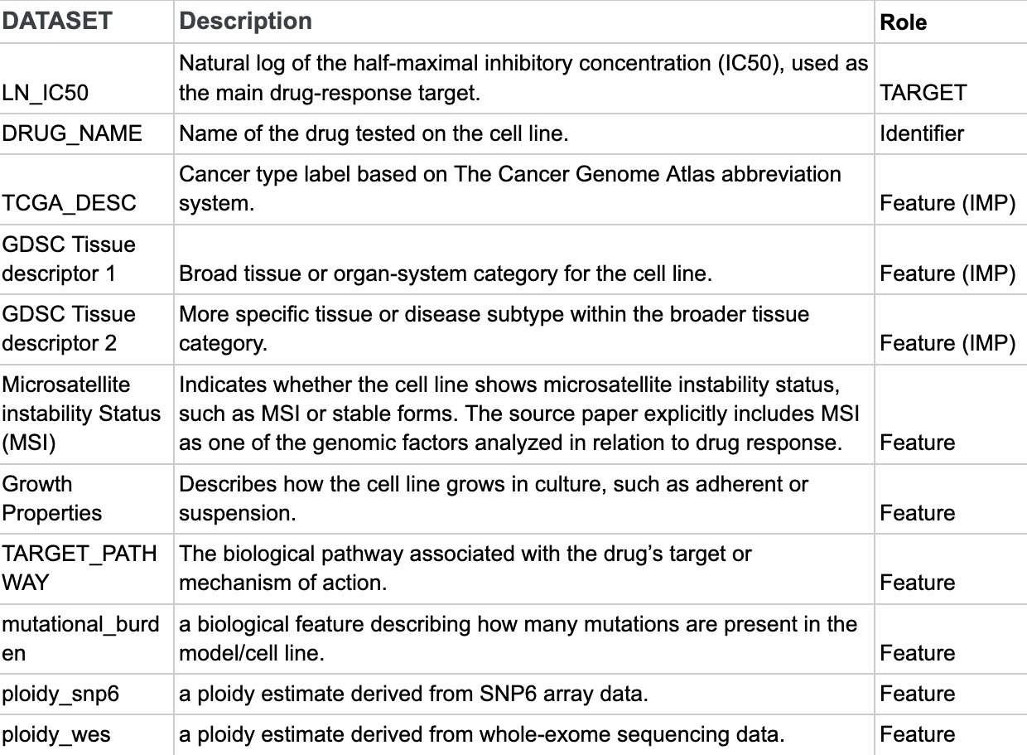
Table 1: A chart of the different variable types used in the project and what they mean

Type of model Built

This model is a three-model tuned regression comparison. It compares CatBoost Regressor, XGBoost Regressor, and LightGBM Regressor. All three models predict LN_IC50 using the same train/test split, processed feature matrix, and evaluation metrics. This makes the model a fair single-model comparison stage before the hybrid/stacked model approach that would be implemented later.

Feature Engineering

Missing-Value Handling

Missing values were handled before model training, so the models could use the full cleaned dataset. For the numeric genomic features, mutational_burden, ploidy_snp6, and ploidy_wes, missing values were replaced using median imputation, with the median calculated from the training data only and then applied to both the training and test sets. Median imputation was used because these genomic variables are continuous and may be skewed, so the median is less affected by extreme values than the mean.
Categorical missing values were handled before encoding. The MSI column was filled as a separate “MISSING” category so the model could retain those rows and treat missing MSI status as its own category during one-hot encoding. Other categorical fields, such as tissue descriptors, growth properties, and TCGA labels, were filled where possible using validated supplementary sources matched by COSMIC_ID; remaining categorical values were handled before one-hot encoding so they would not break the modeling process.

Encoding

Encoding was used to convert categorical predictors into numeric features that the machine learning models could interpret. Two separate encoding strategies were used because the categorical variables had different levels of complexity; lower-cardinality categorical features such as TCGA cancer labels, GDSC tissue descriptors, Growth Properties, MSI status, & TARGET_PATHWAY were handled with one-hot encoding because they represent categories without a natural numeric order. This allowed the models to use cancer type, tissue context, growth behavior, MSI status, and drug-pathway information without incorrectly treating the categories as ranked values. DRUG_NAME was handled separately using cross-validation target encoding because it had many unique drug categories. One-hot encoding DRUG_NAME would have created a very large and sparse feature space. Target encoding replaced each drug name with a numeric value based on that drug’s average LN_IC50 pattern. Cross-validation target encoding was used to reduce data leakage because the encoded values were learned from training folds instead of directly using each row’s own target value. This was important because drug identity was expected to carry a strong predictive signal, but it needed to be represented carefully so the model could learn drug-response patterns without simply memorizing the target.

Standardization

Quantile transformation was used to scale selected numeric predictors after encoding and imputation. The transformed numeric columns were: DRUG_NAME_target_enc, mutational_burden, ploidy_snp6, & ploidy_wes. Quantile transformation was useful because these numeric features may not follow a normal distribution. Instead of only centering and scaling values like StandardScaler, QuantileTransformer reshapes the feature distribution using quantiles and maps the selected numeric features into a more normal-like distribution. This helped reduce the effect of skewed distributions and extreme values in genomic predictors such as mutational_burden. The transformer was fitted only on the training data and then applied to both the training and test sets. This prevented information from the test set from influencing the scaling process. One-hot encoded columns were not transformed because they were already binary 0/1 indicators. The final transformed matrices were saved as X_train_scaled & X_test_scaled. These transformed matrices were then passed into the model algorithms for training and evaluation.

Safe feature name mapping

Safe feature names were created for XGBoost and LightGBM. Encoded feature names can contain spaces, punctuation, parentheses, or long labels. These can sometimes cause compatibility issues.

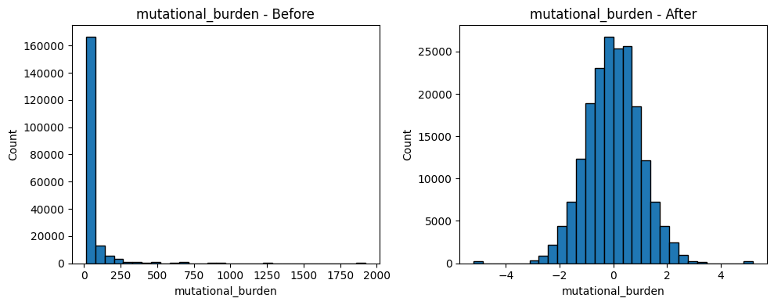
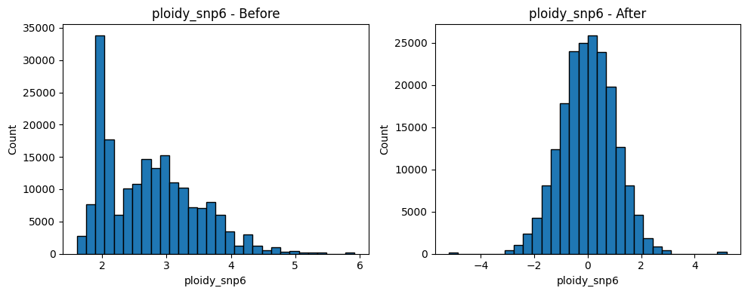
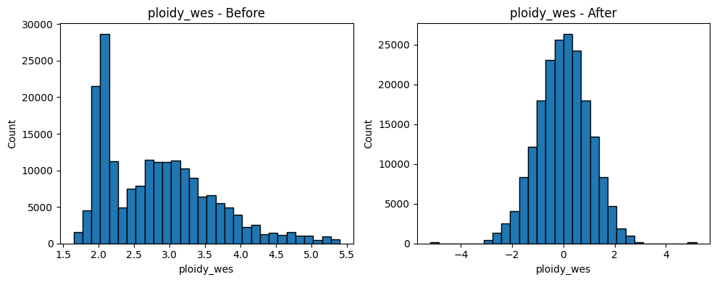
Figure 1: Numeric Feature Standardization; Standardization rescales numeric predictors while preserving distribution shapes.

Index | Original Feature Name | Safe Feature Name
1 | TCGA_DESC_ACC | f_0000
2 | TCGA_DESC_ALL | f_0001
3 | TCGA_DESC_BLCA | f_0002
4 | TCGA_DESC_BRCA | f_0003
5 | TCGA_DESC_CESC | f_0004
... | ... | ...
142 | TARGET_PATHWAY_p53 pathway | f_0141
143 | mutational_burden | f_0142
144 | ploidy_snp6 | f_0143
145 | ploidy_wes | f_0144
146 | DRUG_NAME_target_enc | f_0145
Table 2: Safe Feature Name Mapping; Maps original encoded feature names to safe names for model compatibility.

Model Description
Model and Parameters
The Model pipeline begins with the final preprocessed dataset containing drug, genomic, cancer-type, tissue-level, growth-property, MSI, and target-pathway features. Missing values were handled through targeted filling and imputation. Categorical variables were encoded based on feature type; lower-cardinality features were one-hot encoded, while the high-cardinality DRUG_NAME feature was handled using cross-validation target encoding. Selected numeric variables, including DRUG_NAME_target_enc, mutational_burden, ploidy_snp6, and ploidy_wes, were transformed using quantile transformation before modeling. The final train and test matrices were then passed into three tuned regression models and evaluated on the same held-out test set.
Data preprocessing ---> Feature engineering ---> Encoding ---> Quantile transformation ---> Model training ---> Evaluation
What learner(s) were used?
The model used three tuned supervised regression learners with CatBoost Regressor, XGBoost Regressor & LightGBM Regressor. These models were selected because they are gradient boosting algorithms that perform strongly on structured/tabular datasets. This made them appropriate for predicting LN_IC50 from mixed drug, genomic, tissue, and pathway-level features. They can capture nonlinear relationships and feature interactions that simpler linear models may miss.
Learner hyperparameters
The three models were trained using tuned hyperparameters, shown in Table 3. The main tuned settings controlled tree number, learning rate, tree depth, subsampling, column sampling, regularization, and minimum leaf/child requirements. These parameters helped each model balance predictive accuracy with generalization. CatBoost, XGBoost, and LightGBM were compared under their tuned configurations using the same processed dataset and the same evaluation metrics. This allowed the team to identify the strongest single-model approach before testing the later hybrid model.

Parameter | CatBoost tuned | XGBoost tuned | LightGBM tuned
iterations | 1500 | — | —
n_estimators | — | 1600 | 1750
learning_rate | 0.1355833032 | 0.06062120533 | 0.05055647999
depth / max_depth | depth = 10 | max_depth = 10 | max_depth = 13
l2_leaf_reg | 0.01578981815 | — | —
subsample | 0.7502720766 | 0.8664841676 | 0.8466836047
random_strength | 0.003571049257 | — | —
bagging_temperature | 2.863575984 | — | —
min_data_in_leaf / min_child settings | min_data_in_leaf = 12 | min_child_weight = 3 | min_child_samples = 10
colsample_bytree | — | 0.663669197 | 0.6984490364
gamma | — | 0.4128223644 | —
reg_alpha | — | 0.001139884908 | 0.2618936045
reg_lambda | — | 5.436779722 | 0.3257262948
num_leaves | — | — | 183
objective / loss_function | loss_function = RMSE | objective = reg:squarederror | objective = regression
eval_metric | R2 | — | —
tree_method | — | hist | —
random_state | 42 | 42 | 42
n_jobs | — | -1 | -1
verbose | 0 | — | -1
Table 3 : Hypertuned Parameters used for the 3 models; These parameters were used for all 3 models

Results

Model Performance
This model was evaluated using RMSE, MAE, and R², which together show prediction error size and how much LN_IC50 variation the models explain. Based on the performance table, all three tuned boosting models performed very similarly. CatBoost had the strongest results with the highest R² (0.857843) and lowest RMSE/MAE (1.041411 / 0.777037). XGBoost was almost identical, while LightGBM was slightly lower but still competitive. This shows that the final feature set worked well across multiple boosting algorithms, with CatBoost selected as the strongest single-model option.
Interpretation
The actual-versus-predicted plots in Figure 2 support the results in Table 4 because all three models follow the diagonal trend closely, meaning predicted LN_IC50 values generally matched actual values. Larger errors appear as brighter points farther from the diagonal, but these are limited to scattered, harder-to-predict observations.
The TCGA-colored CatBoost plot shows that multiple cancer groups follow the same overall prediction trend, suggesting the model learned a shared drug-response pattern across cancer contexts. The TCGA residual boxplot further supports this because most cancer groups are centered near zero, although some groups show wider error spread. The drug-level residual plot shows a similar pattern: most drugs have residuals near zero, but some drugs, such as Docetaxel and Dactinomycin, have more variable errors, suggesting certain drug-response patterns are harder to predict consistently.
Model | RMSE | MAE | R²
CatBoost tuned | 1.041411 | 0.777037 | 0.857843
XGBoost tuned | 1.041933 | 0.777403 | 0.8577
LightGBM tuned | 1.047572 | 0.781412 | 0.856156
Table 4: Model Performance after OPTUNA-based hyper-tuning
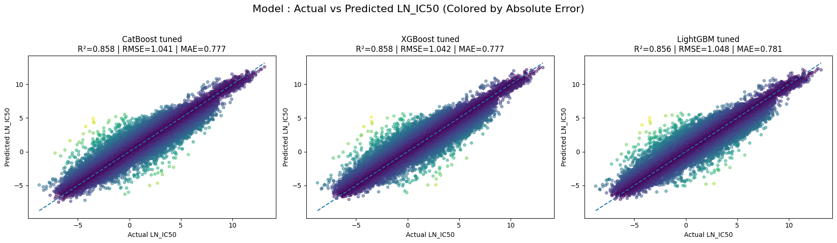
Figure 2: Actual vs. Predicted LN_IC50 Across Tuned Model Algorithms; Tuned models closely follow the diagonal, showing strong LN_IC50 prediction accuracy.
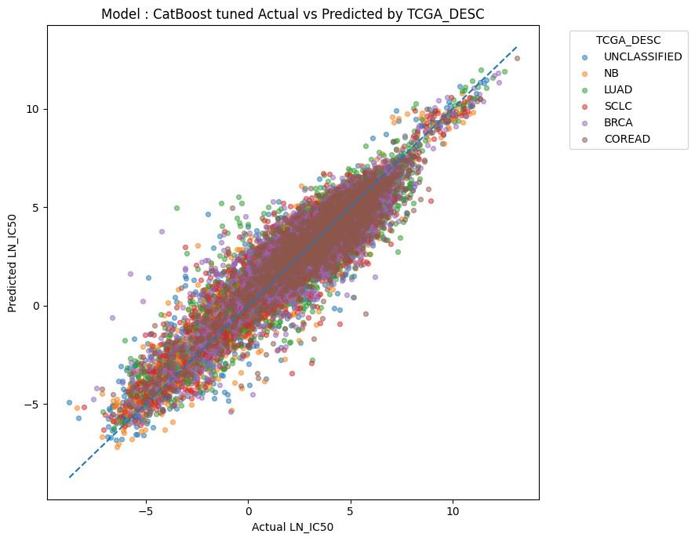
Figure 3: CatBoost Actual vs. Predicted LN_IC50 by TCGA Cancer Group; TCGA groups mostly follow the diagonal, suggesting consistent cross-cancer prediction patterns.
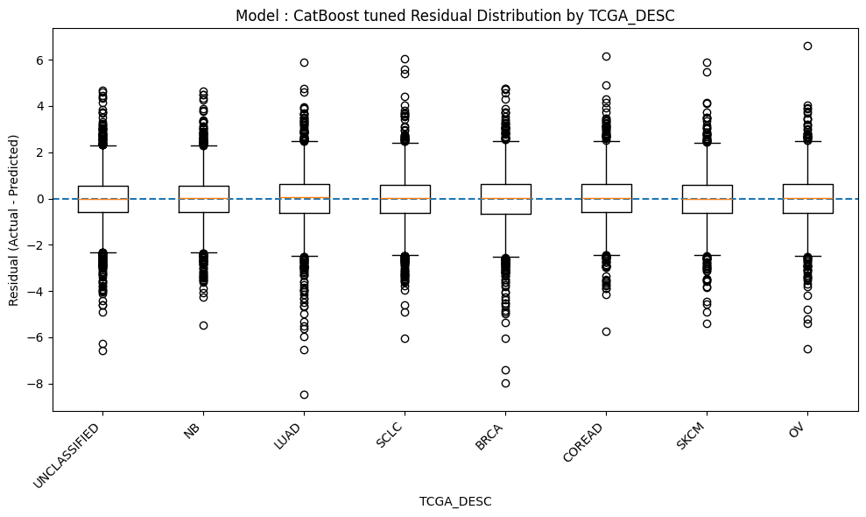
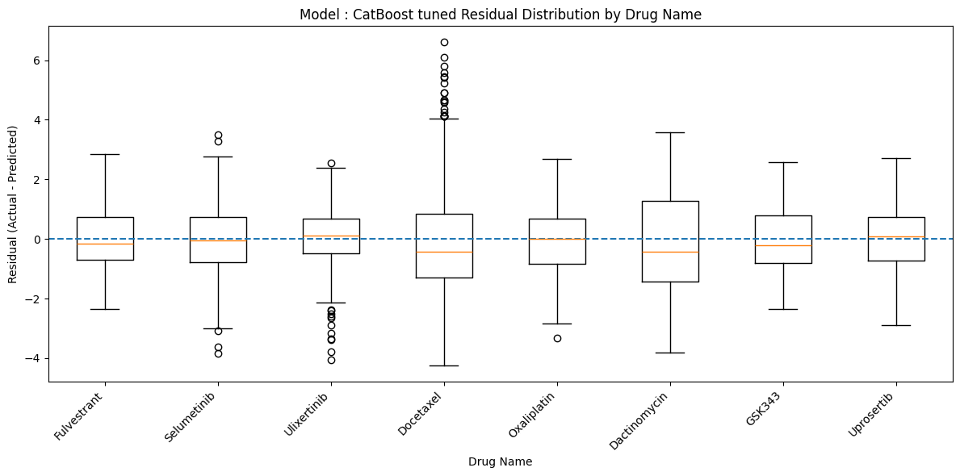
Figure 4: CatBoost Residual Distributions by TCGA Cancer Group and Drug Name; Panel A shows residuals by TCGA group; Panel B shows residuals by drug name.

Model Understanding
Variable Importance
DRUG_NAME_target_enc remained one of the strongest predictors in the tuned models, especially in CatBoost tuned and LightGBM tuned, showing that drug identity continued to carry a large share of the predictive signal for LN_IC50. The genomic variables mutational_burden, ploidy_wes, and ploidy_snp6 ranked among the most influential features in CatBoost tuned and LightGBM tuned, indicating that genomic instability and chromosome-level variation contributed strongly to prediction. Multiple TARGET_PATHWAY categories, including ERK MAPK signaling, DNA replication, Apoptosis regulation, PI3K/MTOR signaling, and Mitosis, appeared among the top features, showing that pathway-level drug mechanisms contributed meaningful predictive signals. Cancer and tissue-context variables such as TCGA_DESC_SCLC, GDSC Tissue descriptor 1_leukemia, and GDSC Tissue descriptor 2_melanoma also appeared repeatedly among the top-ranked predictors, indicating that disease background continued to support the prediction task.
Insight Derived from the Model
The tuned models suggest that drug sensitivity is explained by a combination of drug identity, genomic state, and biological context, rather than by any single variable alone. The continued importance of DRUG_NAME_target_enc indicates that the models first learn that different drugs have distinct response patterns, which is expected in a pharmacogenomics setting. The strong presence of mutational_burden, ploidy_wes, and ploidy_snp6 suggests that genomic instability plays a major role in explaining why some cancer cell lines are more sensitive or resistant to treatment. The repeated appearance of Growth Properties, TCGA_DESC, and GDSC tissue descriptors indicates that cell-line behavior and cancer-type background add important context that helps refine the drug-response prediction.
Overall, the tuned models suggest that LN_IC50 prediction depends on interactions between the tested drug, the genomic condition of the cell line, and the cancer/tissue environment, which also helps explain why tuned nonlinear boosting models performed strongly.
Feature | MeanAbsSHAP
DRUG_NAME_target_enc | 1.713758
Growth Properties_Suspension | 0.24658
ploidy_wes | 0.182247
mutational_burden | 0.148414
ploidy_snp6 | 0.133934
GDSC Tissue descriptor 1_leukemia | 0.05633
TCGA_DESC_NB | 0.033683
TARGET_PATHWAY_ERK MAPK signaling | 0.033457
GDSC Tissue descriptor 1_lymphoma | 0.02756
TARGET_PATHWAY_DNA replication | 0.024099
TARGET_PATHWAY_PI3K/MTOR signaling | 0.020741
Growth Properties_Adherent | 0.020198
GDSC Tissue descriptor 2_pancreas | 0.020076
GDSC Tissue descriptor 1_lung_NSCLC | 0.019812
TCGA_DESC_SCLC | 0.019234
Table 5: Top 15 Model SHAP Features; Mean absolute SHAP values rank the strongest contributors to LN_IC50 prediction.
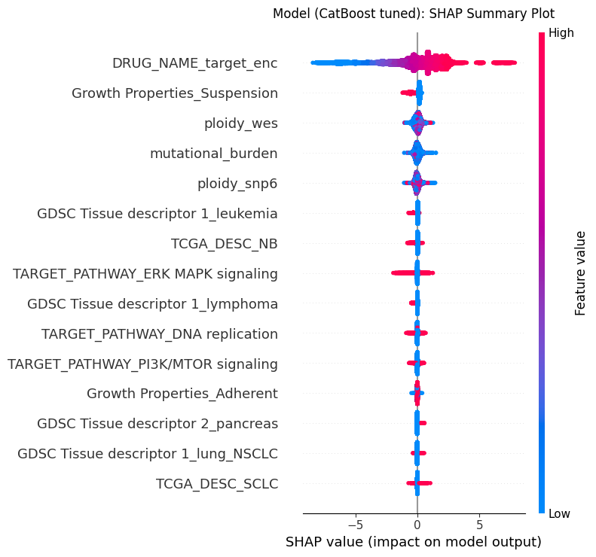
Figure 5: Model SHAP Summary Plot; SHAP values show feature importance and prediction direction for Models.
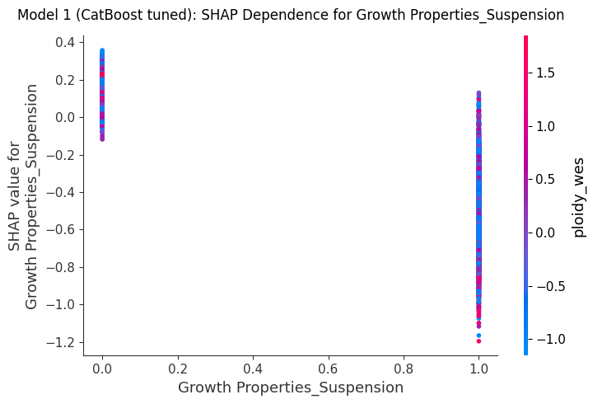
Figure 6: SHAP Dependence Plot for Suspension Growth; This plot shows how the binary feature Growth Properties_Suspension affects CatBoost LN_IC50 predictions. 0 represents non-suspension cell lines, and points at 1 represent suspension-growing cell lines. Most suspension points have negative SHAP values, meaning this feature tends to lower predicted LN_IC50, which suggests greater modeled drug sensitivity.
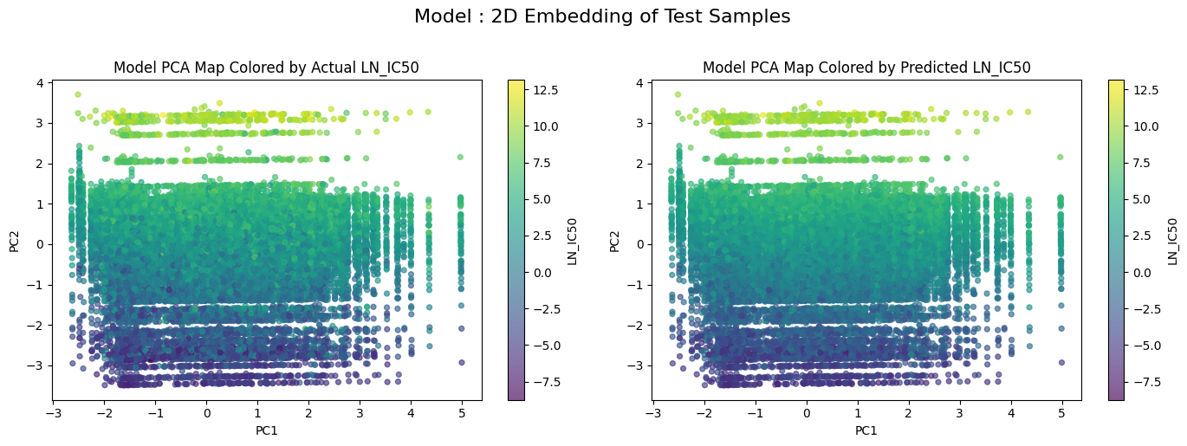
Figure 7: PCA Embedding of Actual and Predicted LN_IC50; PCA shows predicted values preserve the broad structure of actual LN_IC50.

Conclusion and Discussions for Next Steps
The modeling results show that predicting LN_IC50 is a highly feasible machine learning task. Both default and hyperparameter tuned models produced results with strong predictive performance. Gradient boosting methods outperformed linear and simple approaches. Specifically, the tuned XGBoost model achieved the best overall performance with an R-squared value of 0.86 and a reduced RMSE and MAE to confirm the substantial portion of the variability in drug response. These results show the relationship between drug sensitivity, genomic characteristics and tissue context are meaningful specifically when nonlinear approaches are capable of capturing complex feature interactions. Hyperparameter tuning improved the models performance significantly, however, the risk of overfitting remains heavily monitored. The risk is relevant due to the high cardinality features like DRUG_NAME_target_enc, which can unintentionally cause the model to memorize drug specific patterns instead of generalizing biological mechanisms. To avoid this we use data splitting and cross validation target encoding and evaluation through multiple metrics. The consistent performance between validation and test result shows controlled overfitting.
In the future, the model could gain additional features such as a drug-level feature that would allow the model to understand the biological mechanisms of drug response opposed to relying on just the drug name. This would improve generalization to new drugs and would show important interactions between drug properties and genomic features. Lastly, more data sources could be implemented to improve the models overall strength and accuracy. Primarily data sources that highlight drug sensitivity patterns through various cell lines. The Cancer Cell Line Encyclopedia provides drug response measurements that could be used in combination with additional patient data to uncover more meaningful results and predictions.

Final Model

Final Model Report

Analytic Approach
Target Definition

The primary target variable for this project is LN_IC50, which is defined as the natural logarithm of the half-maximal inhibitory concentration. LN_IC50 was selected because it provides the best balance of statistical dispersion, biological interpretability, and alignment with established GDSC drug-response endpoints, compared to alternatives such as AUC and Z-scores. The modeling task is framed as a supervised regression problem, with LN_IC50 treated as a continuous outcome, enabling precise prediction of drug sensitivity across diverse cancer cell lines.
Inputs
The model used the final preprocessed train/test matrices: X_train_scaled, X_test_scaled, y_train & y_test. The modeling file did not redo the preprocessing and used the final model-ready matrices. Table 1 describes all of the features used for modeling in depth. This includes the drug identity feature DRUG_NAME_target_enc, the cancer and tissue descriptors TCGA_DESC, GDSC Tissue descriptor 1, GDSC Tissue descriptor 2, and the genomic features mutational_burden, ploidy_snp6, ploidy_wes.

Table 1: A chart of the different variable types used in the project and what they mean

For the hybrid model, these processed features were first passed into the tuned CatBoost and XGBoost base learners. Each base model generated its own LN_IC50 prediction, and those two prediction outputs became the inputs for the second-layer linear regression model. This allowed the final model to combine CatBoost and XGBoost predictions into one stacked LN_IC50 prediction.

Type of model Built

The final model is a stacked hybrid regression model. It combines two of the tuned base learners, CatBoost Regressor and XGBoost Regressor, with a second-layer linear regression model. CatBoost and XGBoost first learn separately from the same preprocessed feature matrix, and each produces its own LN_IC50 prediction. These two predictions are then passed into the linear regression stacking layer, which learns how to weight and combine them into one final prediction. In the previous 3-model approach, CatBoost, XGBoost, and LightGBM were compared as independent single models. In the final hybrid model, CatBoost and XGBoost are combined. The goal is to use the complementary strengths of both well-performing models so the final prediction is not dependent on one learner’s patterns or mistakes. This approach was taken because cancer drug response is nonlinear and interaction-heavy, involving drug identity, pathway information, tissue context, growth behavior, and genomic instability features.

Feature Engineering

Missing-Value Handling

Missing values were handled before model training, so the models could use the full cleaned dataset. For the numeric genomic features mutational_burden, ploidy_snp6, and ploidy_wes, missing values were replaced using median imputation, with the median calculated from the training data only and then applied to both the training and test sets. This strategy was used because these genomic variables are continuous and may be skewed, so the median is less affected by extreme values than the mean. Categorical missing values were handled before encoding. The MSI column was filled as a separate “MISSING” category so the model could retain those rows and treat missing MSI status as its own category during one-hot encoding. Other categorical fields such as tissue descriptors, growth properties, and TCGA labels were filled where possible using validated supplementary sources matched by COSMIC_ID; remaining categorical values were handled before one-hot encoding so they would not break the modeling process.

Encoding

Encoding was used to convert categorical predictors into numeric features that the machine learning models could interpret. Two separate encoding strategies were used because the categorical variables had different levels of complexity; lower-cardinality categorical features such as TCGA cancer labels, GDSC tissue descriptors, Growth Properties, MSI status, & TARGET_PATHWAY were handled with one-hot encoding because they represent categories without a natural numeric order. This allowed the models to use cancer type, tissue context, growth behavior, MSI status, and drug-pathway information without incorrectly treating the categories as ranked values. DRUG_NAME was handled separately using cross-validation target encoding because it had many unique drug categories. One-hot encoding DRUG_NAME would have created a very large and sparse feature space. Target encoding replaced each drug name with a numeric value based on that drug’s average LN_IC50 pattern. Cross-validation target encoding was used to reduce data leakage because the encoded values were learned from training folds instead of directly using each row’s own target value. This was important because drug identity was expected to carry a strong predictive signal, but it needed to be represented carefully so the model could learn drug-response patterns without simply memorizing the target.

Standardization

Quantile transformation was used to scale selected numeric predictors after encoding and imputation. The transformed numeric columns were: DRUG_NAME_target_enc, mutational_burden, ploidy_snp6, & ploidy_wes. Quantile transformation was useful because these numeric features may not follow a normal distribution. Instead of only centering and scaling values like StandardScaler, QuantileTransformer reshapes the feature distribution using quantiles and maps the selected numeric features into a more normal-like distribution. This helped reduce the effect of skewed distributions and extreme values in genomic predictors such as mutational_burden. The transformer was fitted only on the training data and then applied to both the training and test sets. This prevented information from the test set from influencing the scaling process. One-hot encoded columns were not transformed because they were already binary 0/1 indicators. The final transformed matrices were saved as X_train_scaled & X_test_scaled. These transformed matrices were then passed into the model algorithms for training and evaluation.

Safe feature name mapping

Safe feature names were created for the XGBoost model. Encoded feature names can contain spaces, punctuation, parentheses, or long labels. These can sometimes cause compatibility issues.

Feature Selection

The final model feature selection plot still shows DRUG_NAME_target_enc as the most important feature, but the ranking is more balanced than the baseline because Growth Properties_Suspension and tissue/cancer-context features also show strong importance. This suggests the final model relied not only on drug identity but also more clearly used growth behavior and disease-background information. The final model correlation heatmap shows mostly low correlations among selected features, meaning the final selected set retained distinct predictors rather than highly redundant ones. Overall, the final model feature selection suggests that the hybrid model preserved the major drug-identity signal while strengthening the role of biological context.
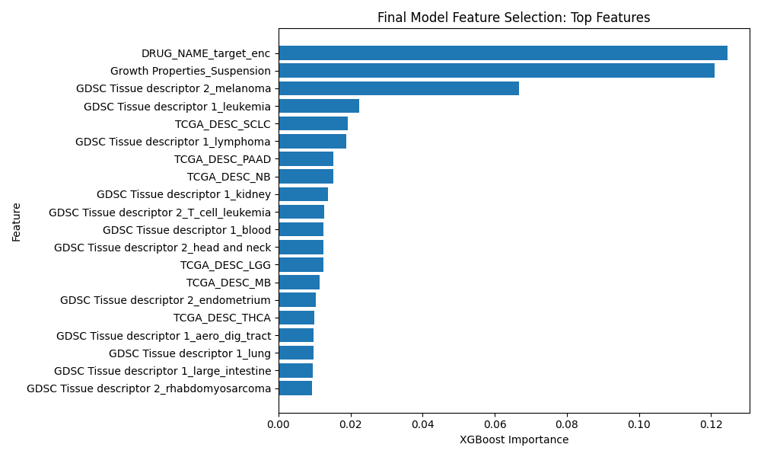
Figure 1: Final Model Feature Selection: Top Selected Features; Shows the top final-model predictors, highlighting drug identity, growth properties, and tissue-context features.

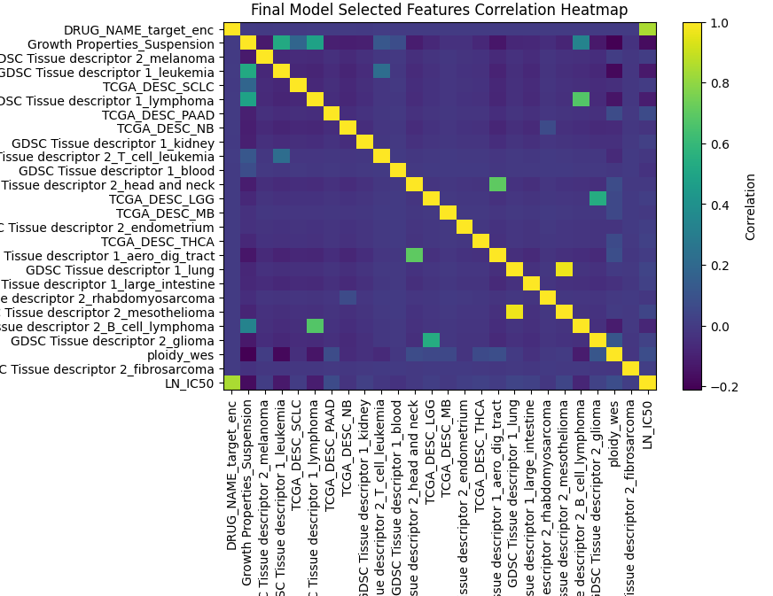
Figure 2: Final Model Selected Features Correlation Heatmap; Displays correlation among final selected features and LN_IC50 to assess redundancy and feature relationships.

Solution Description
Solution

The final solution uses the cleaned and feature-engineered GDSC-based dataset to predict LN_IC50, which represents cancer drug sensitivity. The solution begins with the final preprocessed train/test matrices created from the preprocessing. These matrices contain encoded drug, pathway, cancer-type, tissue, growth-property, MSI, and genomic features. The main modeling solution is a stacked hybrid regression system. First, the same processed training data is passed into two tuned base models, CatBoost and XGBoost. Each model independently learns patterns between the input features and LN_IC50. CatBoost and XGBoost are used together because they are both strong gradient boosting models, but they can capture slightly different nonlinear relationships and make different prediction errors. After the base models generate predictions, their outputs are used as the input to a second-layer linear regression model. This second layer learns how to combine the CatBoost and XGBoost predictions into one final stacked prediction. In simple terms, the final model asks both base models for their predicted LN_IC50 value, then learns the best weighted combination of those two predictions.

Data flow:
Datasets ---> preprocessing ---> final model-ready matrices ---> CatBoost and XGBoost base predictions --->Linear Regression stacking layer --->final predicted LN_IC50

Output

The final output is a predicted LN_IC50 value for each cancer type and drug combination in the test set. This prediction can be interpreted as the model’s estimate of drug sensitivity. Lower predicted LN_IC50 values suggest stronger predicted sensitivity, while higher values suggest weaker sensitivity or greater resistance. These outputs can also support the dashboard by ranking drug responses, comparing treatment options, and showing prediction patterns across cancer/genomic profiles.

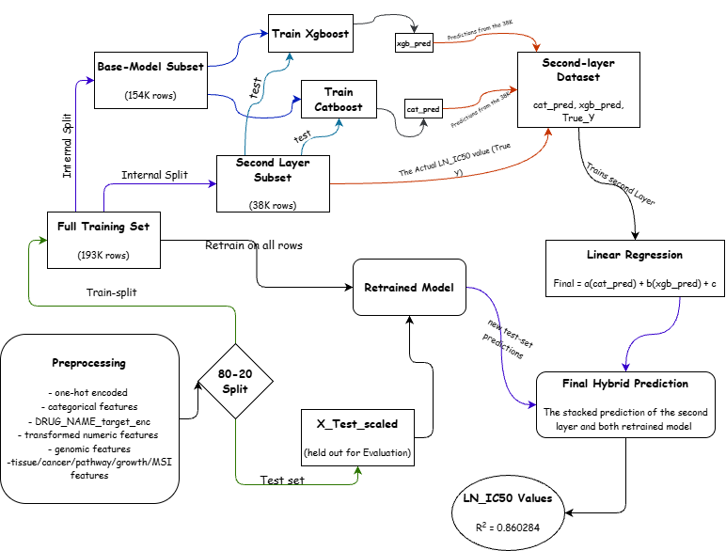
Figure 3: Final Hybrid Model Solution Architecture; Shows the full stacking workflow, including preprocessing, internal training/validation splits, CatBoost and XGBoost prediction generation, second-layer Linear Regression, and final held-out LN_IC50 prediction.

Data
Source
The final model used GDSC_DATASET.csv as the main drug-response dataset. This file was sourced from Kaggle, where it was uploaded by a user who compiled it from the official Genomics of Drug Sensitivity in Cancer, or GDSC, database. The original data was produced by the Sanger Institute and the Broad Institute as part of the GDSC2 screening project. This dataset contains the main drug-response measurements, including LN_IC50, AUC, and Z_SCORE, for 969 cancer cell lines across 345 drugs.
Additional supporting files were used to improve biological completeness during preprocessing. genomic_features.csv came directly from the official GDSC website and contains gene-level mutation and copy-number alteration information in long format, with one row per cell line per genetic feature. This file was used to support genomic feature integration. model_list_latest.csv came from Cell Model, maintained by the Wellcome Sanger Institute, and provided cell-line metadata such as tissue type, cancer subtype, MSI status, growth properties, and COSMIC_ID. This file helped fill missing tissue descriptor, MSI, and growth-property values. Model.csv came from the DepMap Portal Public 25Q2 release and provided Oncotree disease classifications, including Oncotree primary disease and subtype, which were used to resolve remaining UNCLASSIFIED TCGA labels during preprocessing.
Data Schema
The final modeling dataset was structured as one row per cancer cell line and drug response observation. It included reference identifiers, raw biological/drug features, engineered predictors, and the target variable LN_IC50. Identifier columns such as COSMIC_ID, CELL_LINE_NAME, and DRUG_ID were kept for reference only and were not used as predictors.
The main feature groups included drug identity, target pathway, TCGA cancer type, GDSC tissue descriptors, MSI status, growth properties, and genomic predictors such as mutational_burden, ploidy_snp6, and ploidy_wes. After preprocessing, categorical features were one-hot encoded, while DRUG_NAME was converted into DRUG_NAME_target_enc using cross-validation target encoding. The final matrices, X_train_scaled and X_test_scaled, each contained 146 encoded/scaled feature columns. For the hybrid model, two additional stacking features were created, cat_pred and xgb_pred, obtained from the CatBoost and XGBoost base models and used as the only inputs to the second-layer linear regression model.
Column / Group | Stage | Type | Description | Modeling Role
COSMIC_ID | Preprocessed dataset | Identifier | Unique identifier for each cancer cell line | Reference only, not used as predictor
CELL_LINE_NAME | Preprocessed dataset | Identifier | Cell line name label | Reference only, not used as predictor
DRUG_ID | Preprocessed dataset | Identifier | Unique identifier for each screened drug | Reference only, not used as predictor
LN_IC50 | Preprocessed dataset | Target | Natural log of IC50, the final regression target | Prediction target
DRUG_NAME | Raw feature | Categorical | Drug identity before encoding | Used to create DRUG_NAME_target_enc
TARGET_PATHWAY | Raw feature | Categorical | Drug target pathway/mechanism category | One-hot encoded predictor
TCGA_DESC | Raw feature | Categorical | Cancer type label based on TCGA abbreviation | One-hot encoded predictor
Microsatellite Instability Status (MSI) | Raw feature | Categorical | MSI category for each cell line | One-hot encoded predictor
Growth Properties | Raw feature | Categorical | Growth behavior such as adherent or suspension | One-hot encoded predictor
GDSC Tissue descriptor 1 | Raw feature | Categorical | Broad tissue grouping | One-hot encoded predictor
GDSC Tissue descriptor 2 | Raw feature | Categorical | More specific tissue or disease grouping | One-hot encoded predictor
mutational_burden | Raw / merged genomic feature | Numeric | Mutation burden per cell line | Quantile-transformed predictor
ploidy_snp6 | Raw / merged genomic feature | Numeric | Ploidy estimate from SNP6 data | Quantile-transformed predictor
ploidy_wes | Raw / merged genomic feature | Numeric | Ploidy estimate from whole-exome sequencing | Quantile-transformed predictor
DRUG_NAME_target_enc | Engineered feature | Numeric | Cross-validation target-encoded drug identity | Final predictor used by base learners
One-hot encoded feature set | Engineered feature block | Binary | Expanded categorical predictors from TCGA, tis... | Final predictor block used by base learners
X_train_scaled / X_test_scaled | Final modeling matrix | Encoded + standardized matrix | Processed feature matrix after encoding and sc... | Input to CatBoost and XGBoost base learners
Table 2: Final Model Data Schema; Legend: Summarizes identifiers, raw features, engineered predictors, and stacking inputs.
Sampling & Selection
The final model used a 2-level split structure. The full processed dataset was divided into a training set with 193,628 rows and a held-out test set with 48,407 rows. The test set was reserved only for final evaluation and was not used to train the stacking layer.
Inside the training set, a second split was created for the hybrid model. This produced a subset with 154,902 rows and another subset with 38,726 rows for the second layer model. The CatBoost and XgBoost were first trained with the 154K subset, and then their predictions on the second subset were used to train the linear regression model. This design helped prevent test-set leakage because the stacking layer learned how to combine model predictions using only training data.
Selection was based on feature availability, preprocessing validity, and relevance to LN_IC50 prediction. Rows were selected if they had usable drug-response information and could be processed through the final feature-engineering pipeline. The final selected predictors included drug identity, drug target pathway, cancer type, tissue descriptors, MSI status, growth properties, and genomic features. Identifier columns were excluded from modeling, and alternate response variables such as AUC and Z_SCORE were not used as predictors to avoid target leakage. The TARGET column was replaced with the adjacent column TARGET_PATHWAY, due to TARGET missing multiple values.
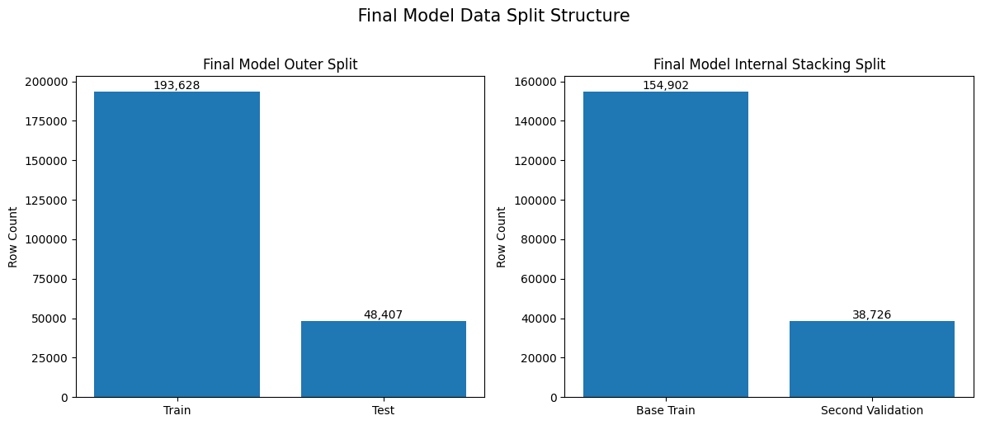
Figure 4: Final Model Data Split Structure; Shows the outer train/test split and internal stacking split used by the hybrid model.
Stats
After preprocessing, the final feature matrix contained 146 encoded/scaled predictor columns. These columns represented the full engineered feature set used by the CatBoost and XGBoost base learners. For the stacking layer, the input was reduced from the full 146-feature matrix to 2 model columns, cat_pred & xgb_pred. These two columns represented the prediction outputs from the CatBoost and XGBoost base models. The linear regression model used only these two prediction columns to produce the final stacked LN_IC50 prediction.

Item | Value
Training rows | 193628
Test rows | 48407
Encoded / scaled feature columns | 146
Base-model training rows | 154902
Second-layer validation rows | 38726
Base-model feature columns | 146
Second-layer validation feature columns | 146
Hybrid model input columns | 2
Hybrid model input names | cat_pred, xgb_pred
Table 3: Final Hybrid Model Dataset and Input Counts; Summarizes the training/test split, encoded feature count, internal hybrid split, and two prediction inputs used by the second-layer model.

Features
The final hybrid model used the feature set created during preprocessing rather than the original raw columns directly. The main inputs included drug identity, target pathway, TCGA cancer type, GDSC tissue descriptors, MSI status, growth properties, and genomic predictors such as mutational_burden, ploidy_snp6, and ploidy_wes. To make these features usable for modeling, the drug names were converted into DRUG_NAME_target_enc using cross-validation target encoding, while lower-cardinality categorical features like MSI, were converted into one-hot encoded predictors.
Numeric predictors were transformed before modeling, producing the final 146-column feature matrix used by the CatBoost and XGBoost base learners. For the second layer of the hybrid model, the two base-model outputs, cat_pred and xgb_pred, were used as the final hybrid input columns.
Feature importance was interpreted using SHAP analysis from the CatBoost base learner. The highest-ranked feature was DRUG_NAME_target_enc, showing that drug identity was the strongest contributor to LN_IC50 prediction. The next important features included Growth Properties_Suspension, ploidy_wes, mutational_burden, and ploidy_snp6, indicating that growth behavior and genomic instability also provided meaningful biological signals. Tissue, cancer-type, and pathway features added smaller but useful supporting context.
Feature | MeanAbsSHAP
DRUG_NAME_target_enc | 1.710028
Growth Properties_Suspension | 0.255086
ploidy_wes | 0.179093
mutational_burden | 0.153209
ploidy_snp6 | 0.132298
GDSC Tissue descriptor 1_leukemia | 0.057537
TARGET_PATHWAY_ERK MAPK signaling | 0.035516
TCGA_DESC_NB | 0.033023
TARGET_PATHWAY_DNA replication | 0.026486
Growth Properties_Adherent | 0.024347
TARGET_PATHWAY_PI3K/MTOR signaling | 0.021442
GDSC Tissue descriptor 1_lymphoma | 0.021204
GDSC Tissue descriptor 1_lung_NSCLC | 0.019081
GDSC Tissue descriptor 2_pancreas | 0.017523
TARGET_PATHWAY_Unclassified | 0.016872
Table 4: Top 15 Final Hybrid Model SHAP Features; Mean absolute SHAP values rank the strongest contributors to LN_IC50 prediction.

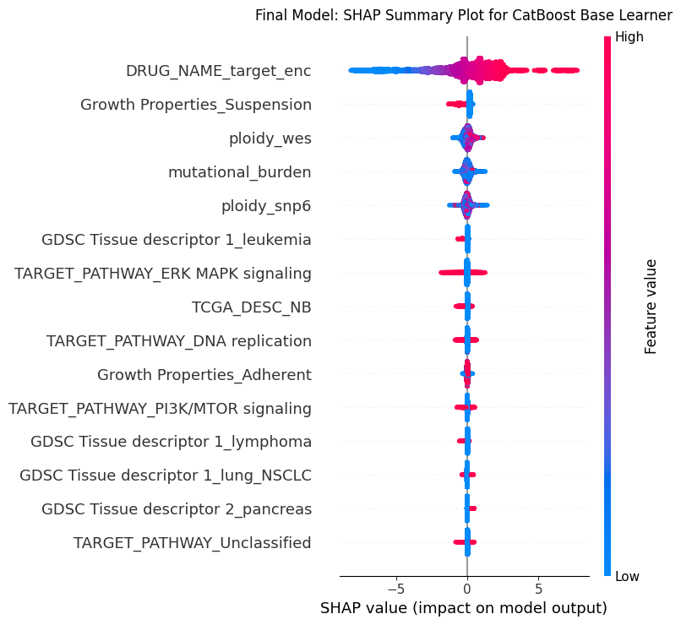
Figure 5: Final Hybrid Model SHAP Summary Plot; This plot shows the most influential features in the final hybrid model. Each row is a feature, ranked from most to least important. The x-axis shows the SHAP value, where positive values push predicted LN_IC50 higher and negative values push predicted LN_IC50 lower. The color shows the feature value, with blue representing lower values and red/pink representing higher values. DRUG_NAME_target_enc has the widest spread, meaning drug identity had the strongest effect on prediction.

Algorithm
Model and Parameters
The model pipeline begins with the final preprocessed dataset containing drug, genomic, cancer-type, tissue-level, growth-property, MSI, and target-pathway features. Missing values were handled through targeted filling and imputation. Categorical variables were encoded based on feature type: lower-cardinality features were one-hot encoded, while the high-cardinality DRUG_NAME feature was handled using cross-validation target encoding. Selected numeric variables, including DRUG_NAME_target_enc, mutational_burden, ploidy_snp6, and ploidy_wes, were transformed using quantile transformation before modeling. The final train and test matrices were then passed into the tuned CatBoost and XGBoost base learners. Each model generated its own LN_IC50 prediction, and those two prediction outputs were passed into a second-layer linear regression model to produce the final hybrid prediction.
Data preprocessing ---> Feature engineering ---> Encoding ---> Quantile transformation ---> CatBoost/XGBoost base predictions ---> Second-layer Linear Regression ---> Final LN_IC50 prediction
What learner(s) were used?
The final hybrid model used three supervised regression components, CatBoost as the first base learner, XGBoost as the second base learner, and linear regression as the second-layer model. These models were selected because they were the strongest models from the earlier 3-model approach, and both are effective for nonlinear tabular prediction. In the final model, they were not used as separate competing models, instead, each produced its own LN_IC50 prediction. These two prediction outputs were then passed into the second-layer linear regression model, which learned how to combine them into one final stacked prediction.
The second-layer model can be represented as - Final predicted LN_IC50 = a(cat_pred) + b(xgb_pred) + c, where cat_pred is the CatBoost prediction, xgb_pred is the XGBoost prediction, a and b are the learned weights assigned to each base model, and c is the intercept term. This means the second layer learns how much to rely on each base-model prediction before producing the final hybrid output.
Learner hyperparameters
The CatBoost and XGBoost base learners were trained using tuned hyperparameters, shown in the table below. The second-layer linear regression model did not require the same type of hyperparameter tuning because it only learned a simple weighted combination of the two base-model predictions. This structure allowed the final model to keep the strengths of CatBoost and XGBoost while using the second layer to produce a more balanced final LN_IC50 prediction.
Parameter | CatBoost | XGBoost
bagging_temperature | 0.43032 | NaN
colsample_bytree | NaN | 0.70303
depth | 12 | NaN
eval_metric | R2 | NaN
gamma | NaN | 0.112268
iterations | 2100 | NaN
l2_leaf_reg | 4.18484 | NaN
learning_rate | 0.127225 | 0.048373
loss_function | RMSE | NaN
max_depth | NaN | 9
min_child_weight | NaN | 4
min_data_in_leaf | 22 | NaN
n_estimators | NaN | 2000
n_jobs | NaN | -1
objective | NaN | reg:squarederror
random_state | 42 | 42
random_strength | 0.229978 | NaN
reg_alpha | NaN | 0.000255
reg_lambda | NaN | 3.099565
subsample | 0.816038 | 0.918038
tree_method | NaN | hist
verbose | 0 | NaN
Table 5: Tuned Hyperparameters for Final Hybrid Base Learners; Lists the tuned CatBoost and XGBoost settings used before second-layer prediction stacking.
Results
Model Performance
The hybrid model was evaluated using RMSE, MAE, and R², which together show prediction error size and how much LN_IC50 variation the models explain. Based on the performance table, the stacked linear layer performed best overall, with the highest R² and the lowest RMSE/MAE. The average blend was almost identical, with an R² of 0.860231, showing that combining CatBoost and XGBoost improved slightly over using either model alone. The base CatBOOST and XGBoost individually performed well. This confirms that both base learners were already highly competitive, but the hybrid approach gave the best final result by learning how to combine their predictions.
Interpretation
The actual-versus-predicted plots support the performance table because all four approaches follow the diagonal trend closely, meaning predicted LN_IC50 values generally matched the actual values. The stacked linear layer and average blend appear slightly tighter than the individual base models, which matches their slightly better RMSE, MAE, and R² values. The TCGA-colored stacked model plot shows that multiple cancer groups follow the same overall prediction trend, suggesting that the hybrid model learned a shared drug-response pattern across cancer contexts. The residual distribution by TCGA group also supports this because most groups are centered near zero, although some cancer groups show wider error spread. Overall, the results show that the final stacked hybrid model provided a modest but meaningful improvement over the individual CatBoost and XGBoost models while keeping prediction errors generally balanced across cancer groups and selected drugs.

Model | RMSE | MAE | R²
Stacked linear layer | 1.032433 | 0.769603 | 0.860284
Average blend | 1.032626 | 0.769966 | 0.860231
CatBoost only | 1.036871 | 0.772769 | 0.85908
XGBoost only | 1.041301 | 0.77674 | 0.857873
Table 6: Final Hybrid Model Performance Results; Compares RMSE, MAE, and R² for CatBoost, XGBoost, average blend, and stacked prediction.

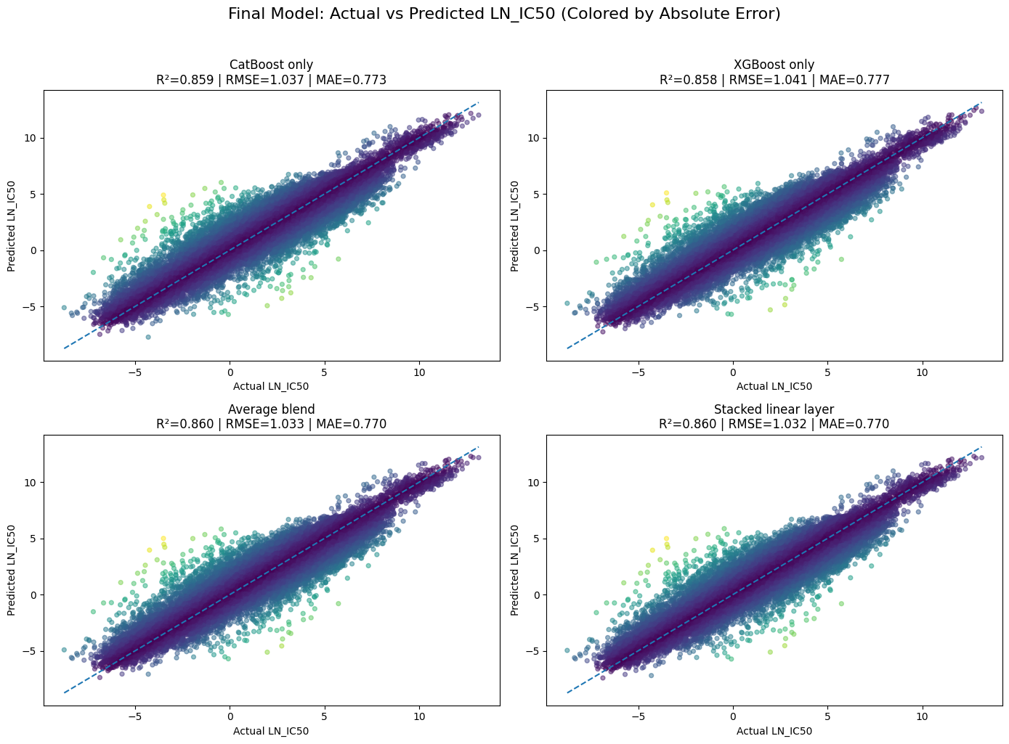
Figure 6: Actual vs. Predicted LN_IC50 Across Final Model Approaches; All approaches follow the diagonal closely, with the stacked model giving the strongest final fit.
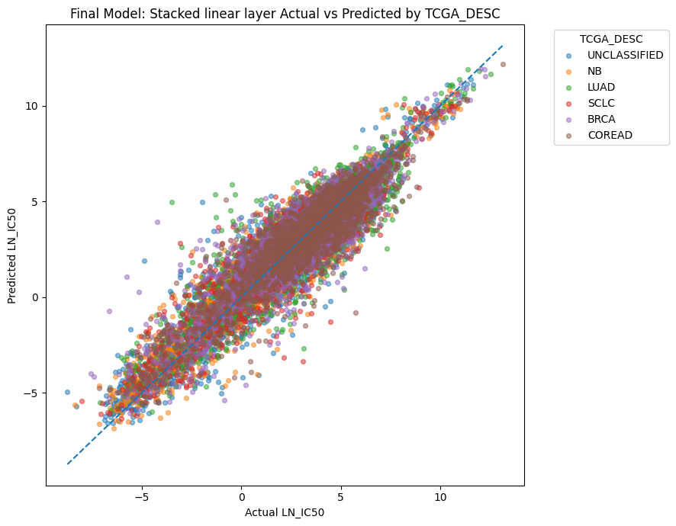
Figure 7: Stacked Model Actual vs. Predicted LN_IC50 by TCGA Cancer Group; TCGA groups follow the same diagonal trend, showing consistent cross-cancer prediction behavior.
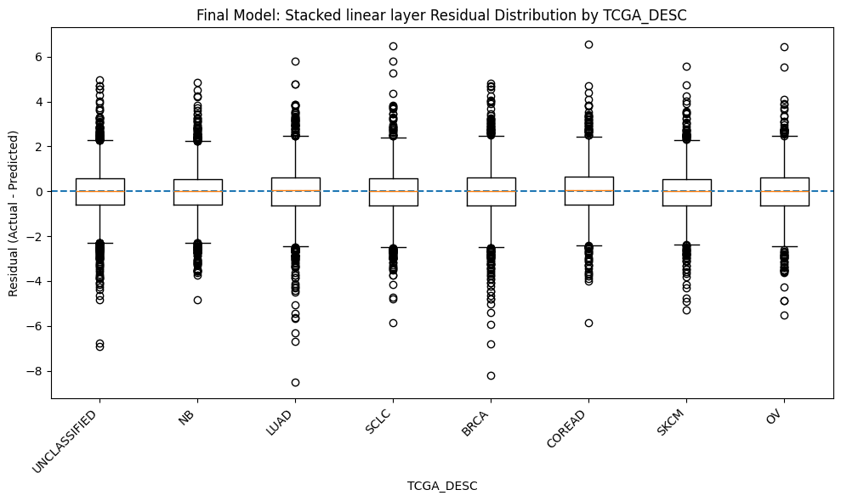
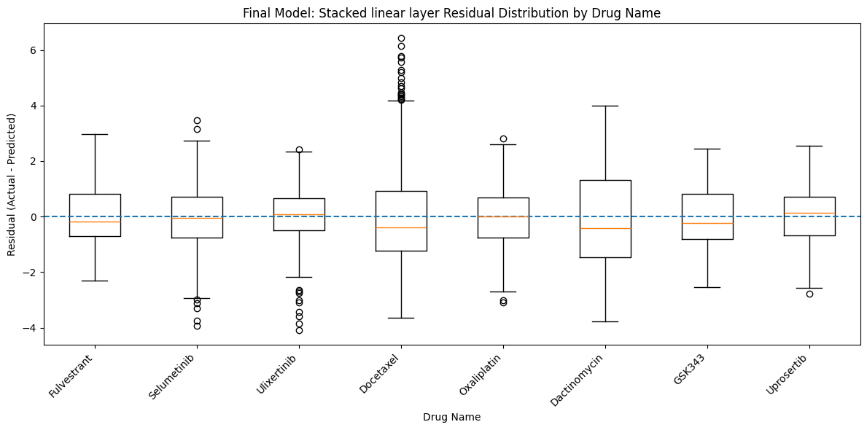
Figure 8: Stacked Model Residual Distributions by TCGA Cancer Group and Drug Name; Panel A compares residuals by cancer group; Panel B compares residuals by selected drug.
Dashboard

The final aspect of our project is to design a dashboard that is intended to be both interactive and a tool to assist healthcare professionals in analyzing cancer drug response. The goal is to allow users to input a cancer-related profile and receive both predicted drug responses and a ranked comparison of different treatment options. The dashboard also includes model comparison, prediction-strength feedback, feature-influence summaries, what-if analysis for selected biological inputs, and chart-based views of ranked drug response patterns to make the predictions more interpretable and easier to compare in context.

